**Distributed systems Introduction**

Distributed systems are an important development for IT and computer science as an increasing number of related jobs are so massive and complex that it would be impossible for a single computer to handle them alone. But distributed computing offers additional advantages over traditional computing environments. Distributed systems reduce the risks involved with having a single point of failure, bolstering reliability and fault tolerance. Modern distributed systems are generally designed to be scalable in near real-time; also, you can spin up additional computing resources on the fly, increasing performance and further reducing time to completion.

**Distributing the Processing and Storage Function in Distributed Systems**

*By* [*Amit Sana*](https://ezinearticles.com/expert/Amit_Sana/1013603)*|   Submitted On April 08, 2011*

[Recommend Article](https://ezinearticles.com/?Distributing-the-Processing-and-Storage-Function-in-Distributed-Systems&id=6159425#/rpc/article/emailArticle/form.json?callback=setupEmailForm)[Article Comments](https://ezinearticles.com/comment.php?Distributing-the-Processing-and-Storage-Function-in-Distributed-Systems&id=6159425)[Print Article](https://ezinearticles.com/?Distributing-the-Processing-and-Storage-Function-in-Distributed-Systems&id=6159425)

[Share this article on Facebook](https://ezinearticles.com/share/?id=6159425&site=facebook)[Share this article on Twitter](https://ezinearticles.com/share/?id=6159425&site=twitter)[Share this article on Linkedin](https://ezinearticles.com/share/?id=6159425&site=linkedin)[Share this article on Reddit](https://ezinearticles.com/share/?id=6159425&site=reddit)[Share this article on Pinterest](https://ezinearticles.com/share/?id=6159425&site=pinterest)

In distributed system, multiple computers are connected on the network working together as a system. These computer are independent but their collection appears to it users as a single coherent system. Distributed system provides sharing of resources and information. Processes executed on these systems can communicate with one another by exchanging messages over communication channel.

The distributed processing refers to LAN designed so that a single program can run simultaneously at various sites. Most distributed processing systems contain sophisticated software that detects idle CPUs on the network and parcels out programs to utilize them.

Another form of distributed processing involves distributed database, databases in which the data stored across two or more computer systems. The database system keeps track of where the data is so that the distributed nature of the database is not apparent to users.

A distributed database consists of two or more data files located at different sites on a computer network. Because the database is distributed, different users can without interfering with one another. However, the DBMS must periodically synchronize the scattered database to make sure they all have consistent data.

The software system that facilitates the the management of a DDB in such a way that the distribution aspects are transparent to users.

----------------------------------------------------------------------------------------------------

### Distribution of parallel processes

Distributed computing is often used in tandem with [parallel computing](https://www.khanacademy.org/a/parallel-computing). Parallel computing on a single computer uses multiple processors to process tasks in parallel, whereas distributed parallel computing uses multiple computing devices to process those tasks.

Consider our example program that detects cats in images. In a distributed computing approach, a managing computer would send the image information to each of the worker computers and each worker would report back their results.

An illustration of distributed parallel computing: a computer with arrows fanning out to four other computers and each arrow is annotated with an image filename.

## Architecture Styles:

To show different arrangement styles among computers Architecture styles are proposed.

### 1. Layered Architecture:

In Layered architecture, different components are organised in layers. Each layer communicates with its adjacent layer by sending requests and getting responses.  The layered architecture separates components into units. It is an efficient way of communication. Any layer can not directly communicate with another layer. A layer can only communicate with its neighbouring layer and then the next layer transfers information to another layer and so on the process goes on.

In some cases, layered architecture is in cross-layer coordination. In a cross-layer, any adjacent layer can be skipped until it fulfils the request and provides better performance results. Request flow from top to bottom(downwards) and response flow from bottom to top(upwards). The advantage of layered architecture is that each layer can be modified independently without affecting the whole system. This type of architecture is used in Open System Interconnection (OSI) model.

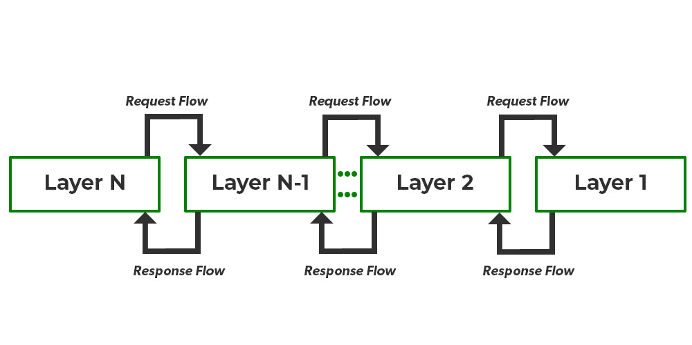

### 2. Object-Oriented Architecture:

In this type of architecture, components are treated as objects which convey information to each other. Object-Oriented Architecture contains an arrangement of loosely coupled objects. Objects can interact with each other through method calls. Objects are connected to each other through the Remote Procedure Call (RPC) mechanism or Remote Method Invocation (RMI) mechanism. Web Services and REST API are examples of object-oriented architecture.

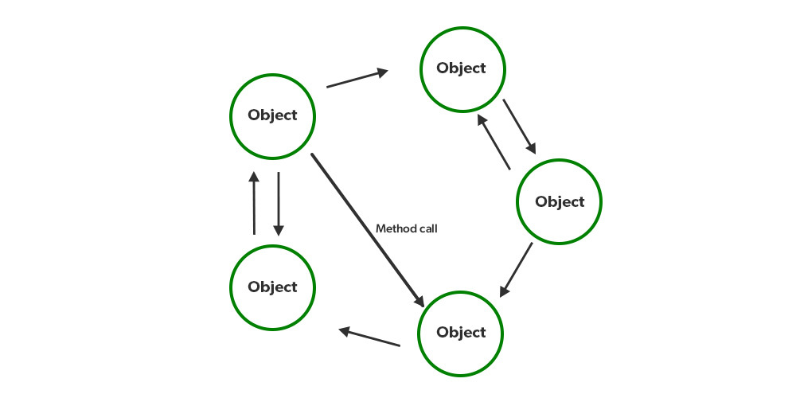

### 3. Data Centred Architecture:

Data Centred Architecture is a type of architecture in which a common data space is present at the centre. It contains all the required data in one place a shared data space. All the components are connected to this data space and they follow publish/subscribe type of communication. It has a central data repository at the centre. Required data is then delivered to the components.

For example Producer-Consumer system. The producer produces data in common data space and consumers request data.

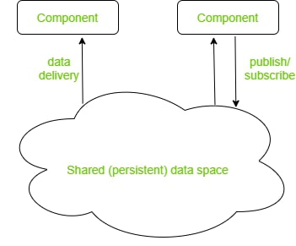

### 4. Event-Based Architecture:

Event-Based Architecture is almost similar to Data centred architecture just the difference is that in this architecture events are present instead of data. Events are present at the centre in the Event bus and delivered to the required component whenever needed. In this architecture, the entire communication is done through events. When an event occurs, the system, as well as the receiver, get notified. Data, URLs etc are transmitted through events. The components of this system are loosely coupled that’s why it is easy to add, remove and modify them. Heterogeneous components can communicate through the bus.

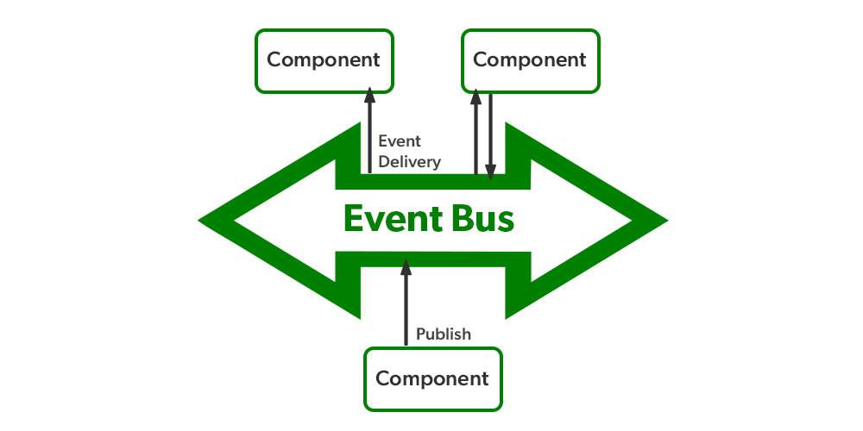

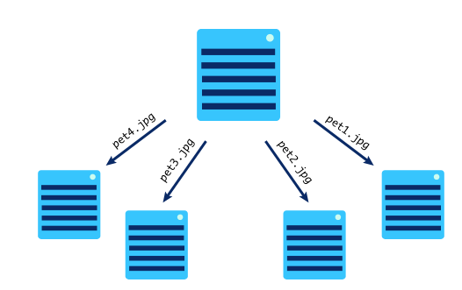

### Evaluating the performance

Distributed computing can improve the performance of many solutions, by taking advantage of hundreds or thousands of computers running in parallel. We can measure the gains by calculating the **speedup**: the time taken by the sequential solution divided by the time taken by the distributed parallel solution. If a sequential solution takes 60 minutes and a distributed solution takes 6666 minutes, the speedup is 10.

Difference between parallel and distributed computing

|  |  |  |
| --- | --- | --- |
| **S.NO** | **Parallel Computing** | **Distributed Computing** |
| 1. | Many operations are performed simultaneously | System components are located at different locations |
| 2. | Single computer is required | Uses multiple computers |
| 3. | Multiple processors perform multiple operations | Multiple computers perform multiple operations |
| 4. | It may have shared or distributed memory | It have only distributed memory |
| 5. | Processors communicate with each other through bus | Computer communicate with each other through message passing. |
| 6. | Improves the system performance | Improves system scalability, fault tolerance and resource sharing capabilities |